AI Powered News Search App with slack bot integration

Project Report

**INDEX**

|  |  |  |  |  |  |  |  |
| --- | --- | --- | --- | --- | --- | --- | --- |
| **1** | |  | **INTRODUCTION** | |  |  |  |
|  | |  | 1.1 Overview | |  |  |  |
|  | |  | 1.2 Purpose | |  |  |  |
| **2** | |  | **LITERATURE SURVEY** | |  |  |  |
|  | |  | 2.1 Existing problem | | |  |  |
|  | |  | 2.2 Proposed solution | | |  |  |
| **3** | |  | **THEORITICAL ANALYSIS** | |  |  |  |
|  | |  | 3.1 Block diagram | |  |  |  |
|  | |  | 3.2 Hardware / Software designing | | |  |  |
| **4** | |  | **EXPERIMENTAL INVESTIGATIONS** | | |  |  |
| **5** | |  | **FLOWCHART** | |  |  |  |
| **6** | |  | **RESULT** |  |  |  |  |
| **7** | |  | **ADVANTAGES & DISADVANTAGES** | | |  |  |
| **8** | |  | **APPLICATIONS** | |  |  |  |
| **9** | |  | **CONCLUSION** | |  |  |  |
| **10** | |  | **FUTURE SCOPE** | | **`** |  |  |
| **11** | |  | **BIBILOGRAPHY** | |  |  |  |
|  | |  | **APPENDIX** | |  |  |  |
|  |  | | A. Source code | |  |  |  |
|  |  | |  |  |  |  |  |

**INTRODUCTION**

**1.1 Overview**

The web is home to massive amounts of data, with more being created every day. Organizations can harness this constant stream of information to gain understanding, plan strategies, and find opportunities. Enriched news data can help your application make dynamic connections across current events faster. In this project, I build news mining web application using Node Red, JavaScript and the Watson Discovery Service. To do this, I have followed the following steps:

* Use code that is written in Node.js (Node Red), with the server-side using the Express framework and the client using ReactJS.
* Use the pre-built Watson Discovery News collection.
* Access the Watson Discovery Service through the Discovery API.
* Use a Slack interface to query the data.
* Host the app on IBM Cloud.

**1.2 Purpose**

This code pattern shows you how to tap into massive data sets to mine insight. You’ll build a news mining web application with the Watson Discovery Service using the Watson Node Red SDK. The app demonstrates two use cases using Watson Discovery News:

* **Search:** Query for the most relevant new articles about a specific topic or subject. Because the news collection is pre-enriched with natural language processing, we can query not just on keywords or categories but also on concepts, sentiment, and relations to get richer search responses.
* **Trending topics in the news:** Identify popular topics over the past 24 hours. Topics can be general or specific to an industry or category.

**LITERATURE SURVEY**

**2.1 Existing problem**

The Existing News search applications are more complex to create and the news which are been rendered are not analyzed properly because of which the customer is not satisfied with the applications.

The news search application is needed to be updated with news on daily bases with increases the complexity of the application and store problem when it comes to small applications. The searching the key words in the collections of large data set, it increases the complexity of the application to search the key words the customer types in. And makes the news search application to render the searched news slower.

**2.2 Proposed solution**

By using IBM Cloud, Node Red and Watson Discovery it makes the application development much easy and reduces the complexity of the application. With the help of News search data set present in Watson discovery makes it easy to set up the news search application and by integrating the news search application with slack bot it creates a platform to make use of the bot for searching the news from there itself.

By using the sentimental analysis for each news which is been rendered based on the latest trends it makes the search application different form other news search applications because the news search application is providing more inform regarding the news which is been rendered based on the users request.

With the help of the sentimental analysis node in node red makes the work easier for analysis and the UI representation in the rendered page respectively. The graph node and some of other nodes present in Node Red makes the work easy and devolvement faster.

**THEORITICAL ANALYSIS**

**3.1 Block diagram**

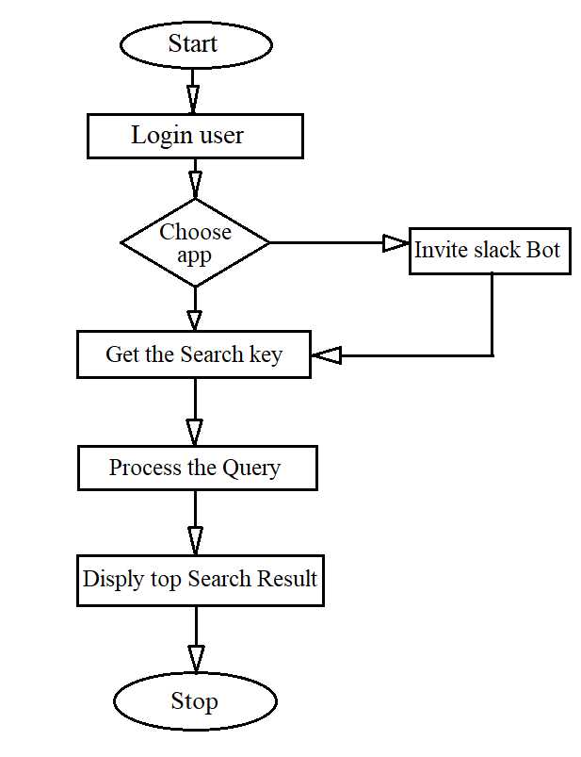

**3.2 Hardware / Software designing**

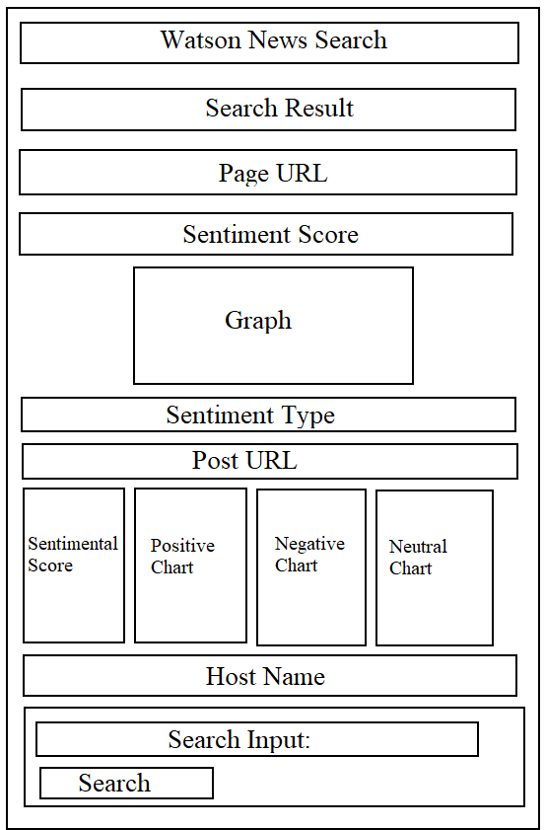

**EXPERIMENTAL INVESTIGATIONS**

In this process of developing the project I have undergone many investigation processes to learn and understand new concepts so that I can build the news search application successfully. For I had to learn and investigate following:

* IBM Cloud.
* Node Red.
* Watson Discovery.
* Slack bot.
* Integrating the Slack bot with Watson discovery.
* ZOHO Writer.

**FLOWCHART**

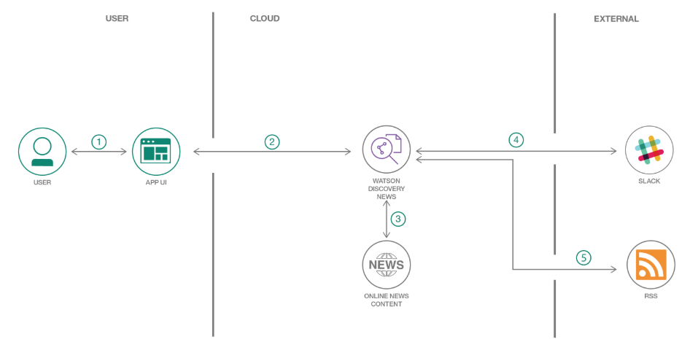

**RESULT**

**UI Interface:**

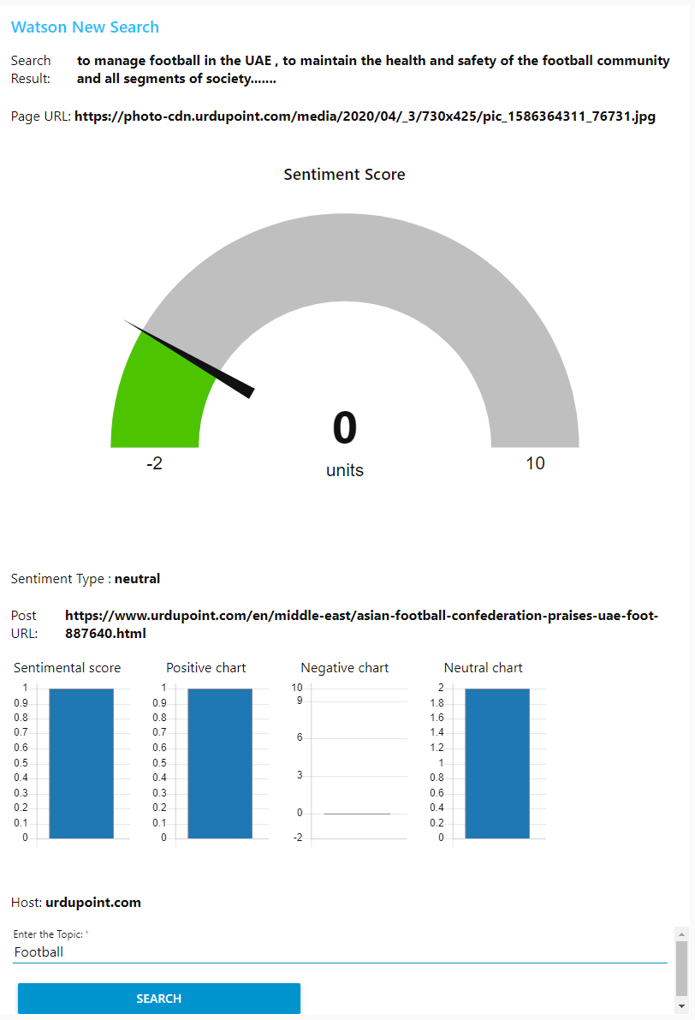

**Slack Bot:**

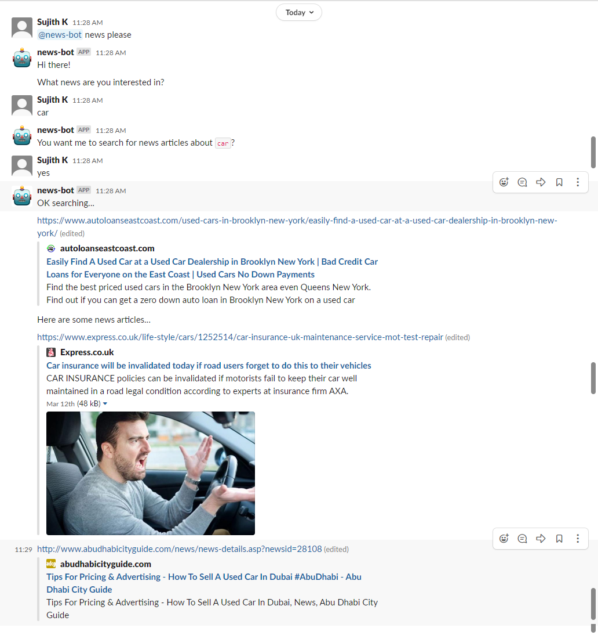

**ADVANTAGES**

The Watson news search application includes following advantages:

* Easy to create.
* Less time required to develop.
* High performance with IBM cloud.

**DISADVANTAGES:**

The Watson news search application includes following disadvantages:

* We need to pay for IBM platform service.
* The services which we use require amount for space we use.

**APPLICATIONS**

The Watson news search application is used to search top trending news from news collections. It can be used for segmental analysis of the search result which is been gathered by queuing the search key provided by the user respectively. With the help of the slack bot integration we can fetch the news directly from slack channel by just inviting the slack bot to the channel and searching for interested news.

**CONCLUSION**

This project gave you some basic working knowledge of the Watson Discovery Service and shows how to use Discovery along with JavaScript and Node Red to build your own news mining web application. This project also tells about the integration process of slack with the Watson services to access and create your own bot to query news from the channel.

**FUTURE SCOPE**

This project can be integrated to other web application because this application can used has a sub module for other big application. Since this application includes the artificial intelligence from Watson discovery it will help in understanding the behavior of the user based on the search results and help in providing user interested news article for the specific user respectively.

**BIBILOGRAPHY**

**Names**: Sujith. K

**College Name**: KPR Institute of Engineering and Technology.

**Work Title:** AI Powered News Search App with slack bot integration.

**References:**

1. News search app Documentation:

<https://developer.ibm.com/patterns/create-a-cognitive-news-search-app/>

1. Slack integration: <https://slack.com/intl/en-in/>
2. IBM Cloud: <https://www.ibm.com/cloud/get-started>
3. Node red tutorial: <https://developer.ibm.com/tutorials/how-to-create-a-node-red-starter-application/>
4. About API:

<https://www.youtube.com/watch?v=s7wmiS2mSXY&feature=youtu.be>

1. Watson services and product: <https://www.ibm.com/watson/products-services>
2. IBM Watson Discovery: <https://developer.ibm.com/articles/introduction-watson-discovery/>
3. Demo application: <https://discovery-news-demo.ng.bluemix.net/>

**APPENDIX**

**Link to Node Red work space:**

<https://news-search-network.eu-gb.mybluemix.net/red/#flow/b349b775.662b18>

**Link to Node Red UI:**

<https://news-search-network.eu-gb.mybluemix.net/ui/#!/0?socketid=f4KiGnLn9Dca9avgAAAB>